Safety equipment
1/ Watch the video and give the meaning of the following signs: https://www.youtube.com/watch?v=izeWHwDCUes
It is a ……………………………. | + YELLOW=
It is a ……………………………. | + BLUE =  + RED =
It is a ……………………………. | + GREEN=  + RED + :
2/ Can you match these colors and shapes with the correct definitions?
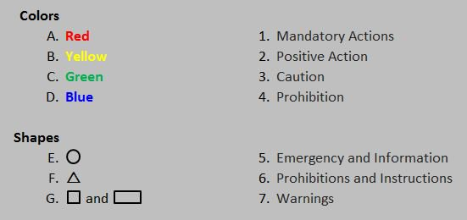

3/ Can you identify these twenty signs that do not include any text?
Refer to instruction manual |  | Do not extinguish with water |  | Pinch point hazard
Drinking water |  | Flammable material |  | Safety harness must be worn
Slide to open |  | Wear welding mask |  | Do not oil
Emergency eyewash station |  | Mandatory, wash hands |  | Biohazard warning
Do not drink |  | Do not walk or stand here |  | Warning, corrosive substance
Breathing apparatus must be worn |  | Emergency stop |  | No naked flames
Emergency meeting point |  | Danger of death

4/ Explain what the following signs correspond to:
Obligation:  - You must + V  - You should + V | Interdiction:  - You mustn’t + V | Possibility:  - You can + V

5/ Take the quiz below:
https://www.mysafetysign.com/free-safety-signs-quiz
