FINAL TASK
Part 1: Oral comprehension
Watch the video and answer the following questions https://youtu.be/4bkr5lpKGUM
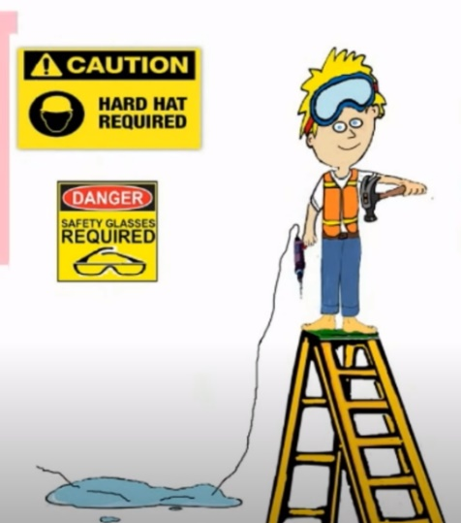
1. A) Explain why this situation is hazardous.
____________________________________________________________
____________________________________________________________
____________________________________________________________
____________________________________________________________
B) What security measures should be taken?
____________________________________________________________
____________________________________________________________
____________________________________________________________
2. Identify
a) the numbers of workers injured every year on-the-job_________________________________________________
b) the number of deaths at work every year: ___________________________________________________________
c) the number of young workers who have accidents at work each year: ____________________________________
d) the number of young people who die from work accident each year: _____________________________________
e) the number of incidents (slips, trips and falls) at work each day:_________________________________________
3. Who is injured very often at work? ________________________________________________________________
4. Explain why young people get injured: _____________________________________________________________
_______________________________________________________________________________________________
_______________________________________________________________________________________________
5. Identify the types of workplace accidents: ___________________________________________________________
_______________________________________________________________________________________________
_______________________________________________________________________________________________
6. What are the causes of accidents in the workplace? ___________________________________________________
_______________________________________________________________________________________________
_______________________________________________________________________________________________
7. Give the solutions to avoid the risk of accidents in the workplace: ________________________________________
_______________________________________________________________________________________________
_______________________________________________________________________________________________
Part 2: Oral expression
You take part in the production of a video tutorial for Erasmus students who will come and visit our school and in particular the maintenance workshop.
You have to inform them about the safety rules of the maintenance workshop.
- You are given a specific place/ machine to present.
- Identify the risks and hazards of the place if you operate a maintenance activity.
- Give information about the safety measures and safety equipment concerning this specific place.
- Video your presentation and send it to your teachers.
An example is given here: https://www.youtube.com/watch?v=y0u-RAO9C0I&ab_channel=HTLWienWest
Follow the scenario below:

